CO2
SIMULATION EXPERIMENT – 5
Electromagnetic Simulation and S-Parameter Characterization of a Microwave Directional Coupler and Two-Way Power Divider.

A. Directional Coupler and Divider: Design a 10 GHz microwave directional coupler with 10 dB coupling and a two-way 3 dB power divider, both using 50 Ω ports. Simulate from 8–12 GHz. At 10 GHz obtain S11, S21, S31 and the isolated-port response. Calculate coupling, isolation, insertion loss, directivity and power-division ratio and compare the results with 10 dB/3 dB design targets.
B. Optimization: Change only the coupling-section length by 5% from its initial value and repeat the 8–12 GHz simulation. Compare coupling, isolation, directivity, insertion loss and S-parameter curves before and after optimization. Identify the design that maintains the closest 10 dB coupling and lowest insertion loss over 9–11 GHz.

Code:
%% Experiment 5: Directional Coupler and Two-Way Divider
clear; clc; close all;

f = linspace(8e9, 12e9, 801);
fGHz = f / 1e9;
f0 = 10e9;

% Illustrative coupler model, set for 10 dB coupling at 10 GHz.
% The +5% change modifies the electrical length.
theta = (pi/2) * f/f0;
theta5 = 1.05 * theta;
targetCoupledPower = 10^(-10/10);

coupledPower = targetCoupledPower .* sin(theta).^2;
coupledPower5 = targetCoupledPower .* sin(theta5).^2;

S31_dB = 10*log10(max(coupledPower, eps));
S31_5_dB = 10*log10(max(coupledPower5, eps));
S21_dB = 10*log10(max(1 - coupledPower, eps));
S21_5_dB = 10*log10(max(1 - coupledPower5, eps));

% Illustrative return loss and isolated-port response
S11_dB = -30 + 20*log10(1 + abs(f-f0)/1e9);
S41_dB = -30 + 2*abs(fGHz - 10);

[~, i10] = min(abs(f-f0));
coupling = -S31_dB(i10);
isolation = -S41_dB(i10);
insertionLoss = -S21_dB(i10);
directivity = isolation - coupling;

fprintf('At 10 GHz:\\n');
fprintf('S11 = %.2f dB, S21 = %.2f dB, S31 = %.2f dB, S41 = %.2f dB\\n', ...
S11_dB(i10), S21_dB(i10), S31_dB(i10), S41_dB(i10));
fprintf('Coupling = %.2f dB; isolation = %.2f dB\\n', coupling, isolation);
fprintf('Insertion loss = %.2f dB; directivity = %.2f dB\\n', ...
insertionLoss, directivity);

% Ideal matched, equal two-way divider
dividerS21_dB = 10*log10(0.5);
dividerS31_dB = 10*log10(0.5);
fprintf('\\nIdeal 3 dB divider: S21 = %.2f dB, S31 = %.2f dB; ratio = 1:1\\n', ...
dividerS21_dB, dividerS31_dB);

% S-parameter curves
figure;
plot(fGHz, S11_dB, fGHz, S21_dB, fGHz, S31_dB, fGHz, S41_dB, ...
'LineWidth', 1.5);
grid on; xlabel('Frequency (GHz)'); ylabel('Magnitude (dB)');
title('Directional Coupler S-Parameters');
legend('S11','S21','S31 coupled','S41 isolated','Location','best');

% Coupling before and after the 5% length change
figure;
plot(fGHz, S31_dB, 'LineWidth', 1.5); hold on;
plot(fGHz, S31_5_dB, '--', 'LineWidth', 1.5);
yline(-10, ':k', '10 dB target');
grid on; xlabel('Frequency (GHz)'); ylabel('S31 (dB)');
title('Coupling Before and After 5% Length Change');
legend('Initial length','Length +5%','Target','Location','best');

% Average comparison over 9-11 GHz
band = f >= 9e9 & f <= 11e9;
fprintf('\\n9-11 GHz average absolute coupling error:\\n');
fprintf('Initial = %.3f dB; +5%% length = %.3f dB\\n', ...
mean(abs(S31_dB(band)+10)), mean(abs(S31_5_dB(band)+10)));
fprintf('Average insertion loss: initial = %.3f dB; +5%% length = %.3f dB\\n', ...
mean(-S21_dB(band)), mean(-S21_5_dB(band)));

output:
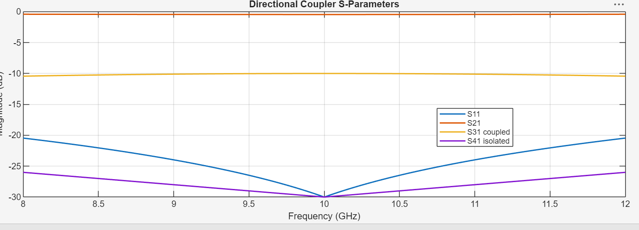
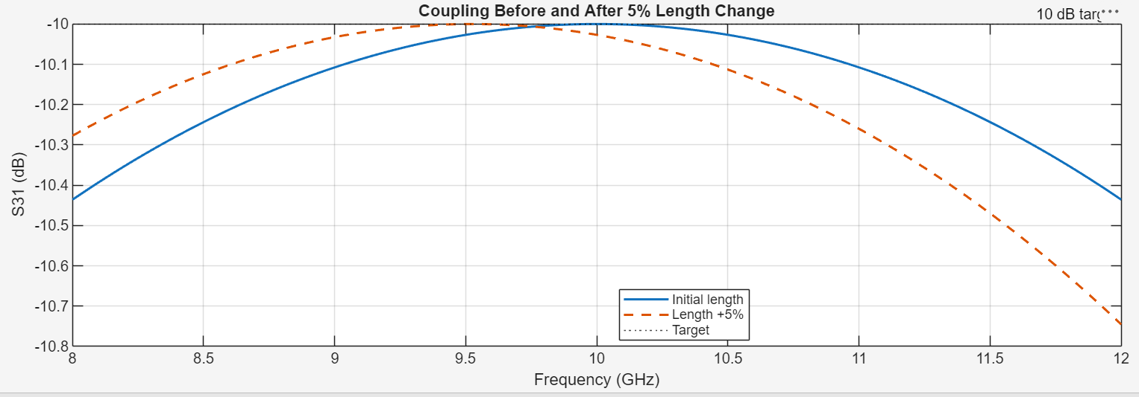

SIMULATION EXPERIMENT – 6
Simulation-Based Investigation of Microwave Semiconductor Devices and Frequency-Conversion Characteristics of a Microwave Mixer

Objectives of this Experiment:
1. To develop simulation models representing the operating characteristics of selected microwave semiconductor devices.
2. To analyze the electrical characteristics and frequency-dependent behavior of Gunn, Schottky or PIN diode-based microwave structures.
3. To simulate frequency conversion in a microwave mixer and identify the generated frequency components.
4. To evaluate conversion characteristics and identify suitable operating conditions for microwave applications.
Experimental Procedure
A. Mixer Frequency Conversion: Set fRF = 10 GHz, fLO = 9.5 GHz, PRF = −10 dBm and PLO = +7

dBm with a 50 Ω IF load. Obtain the output spectrum. Calculate the theoretical IF frequency |10−9.5| =
0.5 GHz and sum frequency 19.5 GHz. Identify the simulated components and calculate the percentage frequency deviation.
B. Conversion Loss: Using the same mixer, record the IF output power at 0.5 GHz. Calculate conversion loss CL = PRF − PIF and compare it with the expected passive-mixer range of approximately 6–10 dB. Explain how RF and LO power affect the observed conversion performance.

Code:
%% Experiment 6: Mixer Frequency Conversion
clear; clc; close all;

% Given mixer settings
fRF = 10e9;
fLO = 9.5e9;
PRF_dBm = -10;
PLO_dBm = 7;

% Theoretical output frequencies
fIF = abs(fRF - fLO);
fSum = fRF + fLO;

fprintf('Theoretical IF frequency = %.3f GHz\\n', fIF/1e9);
fprintf('Theoretical sum frequency = %.3f GHz\\n', fSum/1e9);

% Example spectrum components.
% Replace these illustrative power values with your simulator readings.
spectrumFreq = [fIF, fLO, fRF, fSum];
spectrumPower_dBm = [-17, PLO_dBm, PRF_dBm, -25];

% Example simulated frequency values; replace with measured/simulated peaks.
simIF = 0.500e9;
simSum = 19.500e9;

ifDeviation = 100 * abs(simIF-fIF)/fIF;
sumDeviation = 100 * abs(simSum-fSum)/fSum;

fprintf('\\nSimulated IF = %.3f GHz; deviation = %.4f%%\\n', ...
simIF/1e9, ifDeviation);
fprintf('Simulated sum = %.3f GHz; deviation = %.4f%%\\n', ...
simSum/1e9, sumDeviation);

% Conversion loss using the example IF output power
PIF_dBm = spectrumPower_dBm(1);
conversionLoss_dB = PRF_dBm - PIF_dBm;

fprintf('\\nExample IF output power = %.2f dBm\\n', PIF_dBm);
fprintf('Conversion loss = PRF - PIF = %.2f dB\\n', conversionLoss_dB);

% Plot example output spectrum
figure;
stem(spectrumFreq/1e9, spectrumPower_dBm, 'filled', 'LineWidth', 1.5);
grid on; xlabel('Frequency (GHz)'); ylabel('Power (dBm)');
title('Illustrative Mixer Output Spectrum');
xticks([0.5 9.5 10 19.5]);
xticklabels({'IF: 0.5','LO: 9.5','RF: 10','Sum: 19.5'});
xlim([0 21]);

output:
